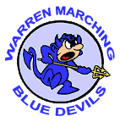

CAR WASH FUNDRAISER!!
What: WTHS Marching Band Color Guard Fundraiser
When: Saturday July 9, 2016 9 A – 3 P
Where: Uno Pizzeria & Grill, 6493 Grand Avenue, Gurnee, IL
(Uno’s parking lot near SW corner of Grand Ave & Hunt Club Rd)
Why: Help offset the cost of their marching costumes, which each student has to purchase themselves
Cost: A monetary donation
Please come out to support this integral part of the high school marching band and get your cars washed at the same time!
Also feel free to tell your family, friends and neighbors!
KEEP THIS DATE OPEN! WE HOPE TO SEE YOU THERE!

